Teste do diagnóstico do covid-19

1-Paciente sem covid-19

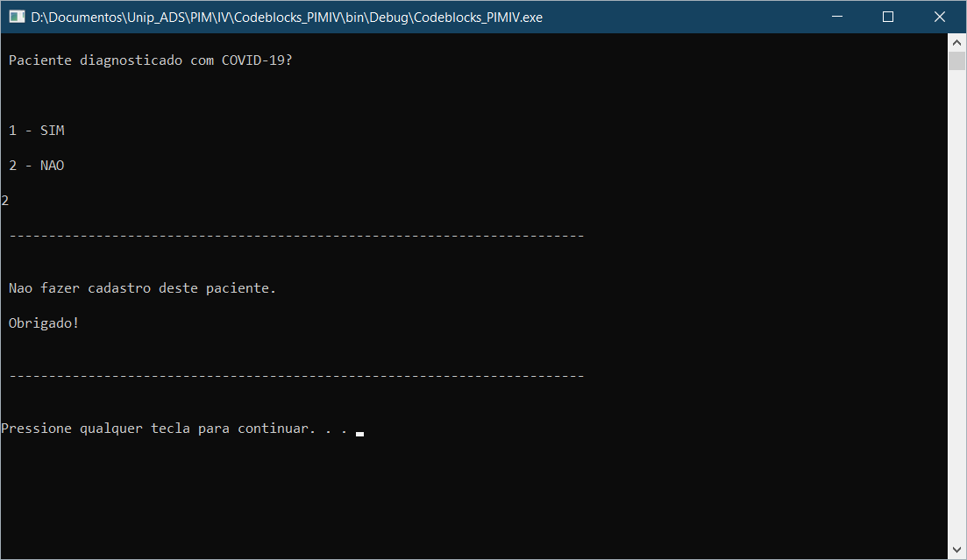

2-Paciente com covid-19

